KuaiKuaiInterMart — Test Execution Report
Week 9 Deliverable | Testing & Quality Assurance
Tool: Pytest 9.0.3 | Django 5.0.4 | Python 3.13.2
Test Date: May 28, 2026
Overall Test Summary
Metric | Result
Unit Tests Collected | 28
Unit Tests Passed | 28
Unit Tests Failed | 0
Integration Tests Collected | 7
Integration Tests Passed | 7
Integration Tests Failed | 0
Total Tests | 35
Total Passed | 35
Overall Pass Rate | 100%
Total Execution Time | ~9 seconds
Overall Result | ✅ ALL TESTS PASSING

Unit Test Results (28/28 Passed)
Command: pytest tests/test_orders_payments.py tests/test_products.py tests/test_users.py -v
Execution Time: 6.57 seconds

Test File | Test Name | Description | Result
test_orders_payments.py | test_create_order_authenticated | Authenticated user can create an order | ✅ PASSED
test_orders_payments.py | test_create_order_unauthenticated | Unauthenticated user cannot create an order | ✅ PASSED
test_orders_payments.py | test_order_list_authenticated | Authenticated user can view their orders | ✅ PASSED
test_orders_payments.py | test_order_list_unauthenticated | Unauthenticated user cannot view orders | ✅ PASSED
test_orders_payments.py | test_order_total_calculated | Order total is correctly calculated from items | ✅ PASSED
test_orders_payments.py | test_simulate_payment | Payment simulation marks order as paid | ✅ PASSED
test_orders_payments.py | test_payment_generates_transaction_id | Payment simulation generates a transaction ID | ✅ PASSED
test_orders_payments.py | test_payment_unauthenticated | Unauthenticated user cannot simulate payment | ✅ PASSED
test_products.py | test_product_list | Product list returns all active products | ✅ PASSED
test_products.py | test_product_list_no_auth_required | Product list is accessible without authentication | ✅ PASSED
test_products.py | test_product_search | Product search returns matching results | ✅ PASSED
test_products.py | test_product_search_no_results | Product search returns empty for non-matching query | ✅ PASSED
test_products.py | test_product_detail | Product detail returns full product info | ✅ PASSED
test_products.py | test_product_detail_regional_prices | Product detail includes regional prices | ✅ PASSED
test_products.py | test_product_detail_not_found | Non-existent product returns 404 | ✅ PASSED
test_products.py | test_category_list | Category list returns all categories | ✅ PASSED
test_products.py | test_product_filter_by_category | Products can be filtered by category | ✅ PASSED
test_products.py | test_add_review_authenticated | Authenticated user can add a review | ✅ PASSED
test_products.py | test_add_review_unauthenticated | Unauthenticated user cannot add a review | ✅ PASSED
test_users.py | test_register_success | User can register with valid data | ✅ PASSED
test_users.py | test_register_password_mismatch | Registration fails when passwords do not match | ✅ PASSED
test_users.py | test_register_duplicate_email | Registration fails with duplicate email | ✅ PASSED
test_users.py | test_login_success | User can login with correct credentials | ✅ PASSED
test_users.py | test_login_wrong_password | Login fails with wrong password | ✅ PASSED
test_users.py | test_login_wrong_email | Login fails with non-existent email | ✅ PASSED
test_users.py | test_get_profile_authenticated | Authenticated user can view their profile | ✅ PASSED
test_users.py | test_get_profile_unauthenticated | Unauthenticated user cannot view profile | ✅ PASSED
test_users.py | test_update_profile | Authenticated user can update their profile | ✅ PASSED

Unit Test Results Snapshot:
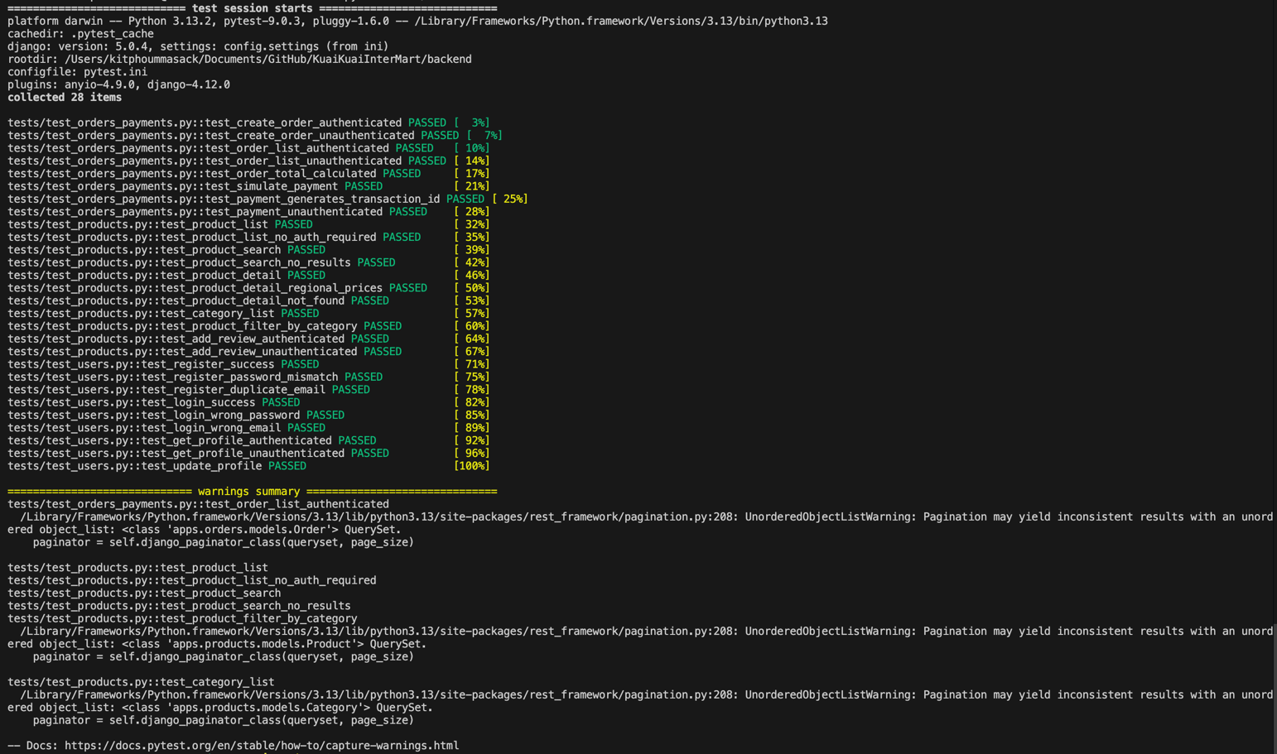
Integration Test Results (7/7 Passed)
Command: pytest tests/test_integration.py -v
Execution Time: 2.60 seconds

Test Name | Flow Description | Result
test_flow_register_login_profile | Register → Login → Get Profile → Update Profile | ✅ PASSED
test_flow_browse_search_detail | Browse Products → Search → View Detail → Check Regional Prices | ✅ PASSED
test_flow_order_and_payment | Register → Login → Create Order → Simulate Payment → Check Order History | ✅ PASSED
test_flow_multiple_payment_methods | Test all 4 payment methods (Credit Card, PayPal, Alipay, WeChat Pay) | ✅ PASSED
test_flow_security_checks | Verify all protected endpoints reject unauthenticated requests | ✅ PASSED
test_flow_product_review | Register → Login → Add Review → Verify Review Appears in Product Detail | ✅ PASSED
test_flow_token_refresh | Login → Get Refresh Token → Use Refresh Token to Get New Access Token | ✅ PASSED

Integration Test Results Snapshot:
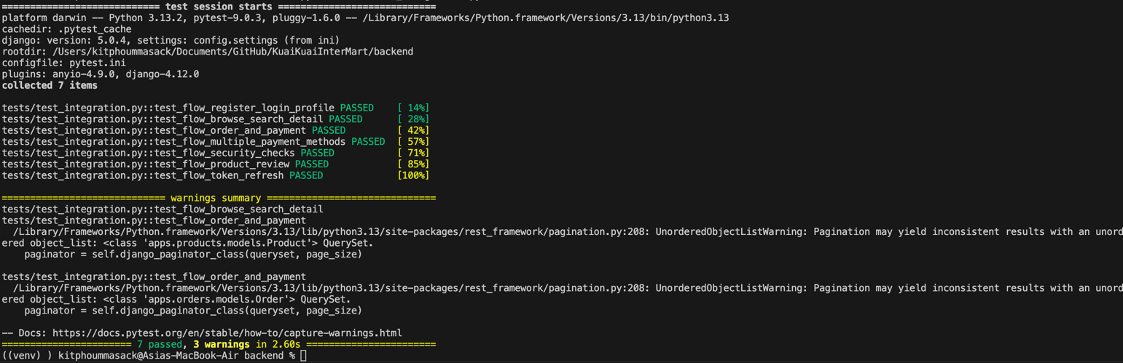
Warnings During Test Execution
3 UnorderedObjectListWarning notices appeared during test execution. These are non-critical warnings from Django REST Framework's pagination system when a queryset does not have an explicit ordering defined. These warnings do not affect test results or application functionality and can be resolved by adding ordering = ["-created_at"] to the relevant model Meta classes in a future update.

Conclusion
All 35 tests passed successfully — 28 unit tests covering individual API endpoints across users, products, orders, and payments modules, and 7 integration tests covering complete end-to-end user flows including registration, login, product browsing, order creation, payment simulation, product reviews, and token refresh.
The test suite confirms that all core features of KuaiKuaiInterMart are functioning correctly and that the frontend-backend integration is working as expected.

